Program Review
Optimisation
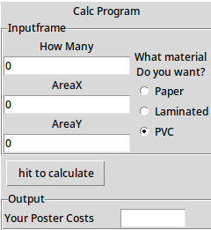
This was the design for the first version of the program, and as such is missing some things i forgot, alongside some text that i changed. Firstly, I changed AreaX and AreaY in the second draft, but i also added a user input box.

In the backend i adjusted some of the code, and input changes, so that it would block bad inputs when entered, using a piece of code that checks whether or not the text entered is a string, or series of integers

I followed up on feedback to do this, feedback for this is on my program Task Sheet

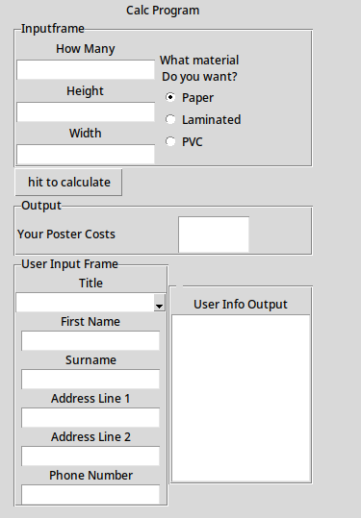
This is the completed program, and as such is expanded, with user info fields and small changes to text, so that it would be more readable to an end user.

In the backend i added the functionality to push the data from the user input, to the user output, alongside the input blocking i had talked about.

I feel that this iteration is useful for the end user, as it now reaches the client requirements set out for me, to develop for, and it looks readable and usable.

When asked for feedback about this build, in the end, none could be given, because it functioned as it should.

Main Body Of Review
The client, required a program to calculate the price of posters, when given a series of inputs, and that it would produce outputs that would be correct, accurate and to the pricing structure of the company, using the company math, that i was given.
I produced a plan, a design, an algorithm, then a command line version, a draft version, and then a completed version of the program. The final design I think, meets the client requirements, as it fulfils all hard requirements given accurately, with the math, and it is event driven, alongside being in a multiplatform language. Furthermore, I have received feedback (As placed in my Task sheets, for plan, design and program) that I then actioned on, if possible.
This was my first UI, event driven program I had developed, and as such, I had struggles. There are many changes I’d make throughout the whole development pipeline, such as creating a better structure for naming input and output fields, recording it in a more readily accessible way, creating a more clean and modern framework. But overall, for a first project, I feel that i achieved what was required of me, and that was enough.
My initial data dictionary did not reflect the end product, as I did not understand the complexity of event driven, UI focused programming, and I would make sure this is better next time. I made good use of efficient programming principles, and i do not feel my program has many extraneous elements that were brought in, through the rocky development cycle.
I feel that if i was going to program something that would be used company wide, and not just for this one element, I would make the design more modular, and less singularly focused, with an OOP solution, but this linear, single-flow approach within the algorithm worked for this problem, and as such the solution is apt for what was required by the client.
Other solutions I had were using a design closer to a modern mobile app, and rearranging the UI elements, but I feel the solution I created is efficient enough, and any changes like this I could make would not warrant a rewrite.
I struggled with timekeeping, and motivation, and would occasionally spend whole weeks not doing any work on the program, nor any documentation, and next time i would plan my time more diligently, and put myself to work more diligently on said work.

